REPORT

Telangana, one of the newly formed state of India with hyderabad, as its megacity is moving forward towards sustainable future. Keeping this in mind, our team has come with a report via analysis on the State's Household Waste & Hospital Waste Management and Transportation as well as the Public Toilets Sanitation.

The entire state of Telangana of 33 districts has a total population of 350.04 Lakhs where **61.12 %** of the total population (ie. 213.95 Lakhs) resides in rural regions whereas the remaining **38.88 %** of the population resides in the urban areas. At the same time, this has also come into light that major portion of waste are generated from the urban local bodies.

**OBJECTIVE**

The main objective of this model is to deep analyse the present situation of waste and sanitation management ongoing in the state and finding the severely effected regions that ends with the recommendation of efficient practices that can be adopted in order to match the SDG goal 7: CLEAN WATER AND SANITATION

CURRENT SCENARIO

Door-to-Door Waste Collection:

The important step, we rather say, responsibility in municipal waste management is the Waste Collection. Thus, Door-to-Door Garbage Collection system plays a crucial and deciding factor of a State's municipal working.

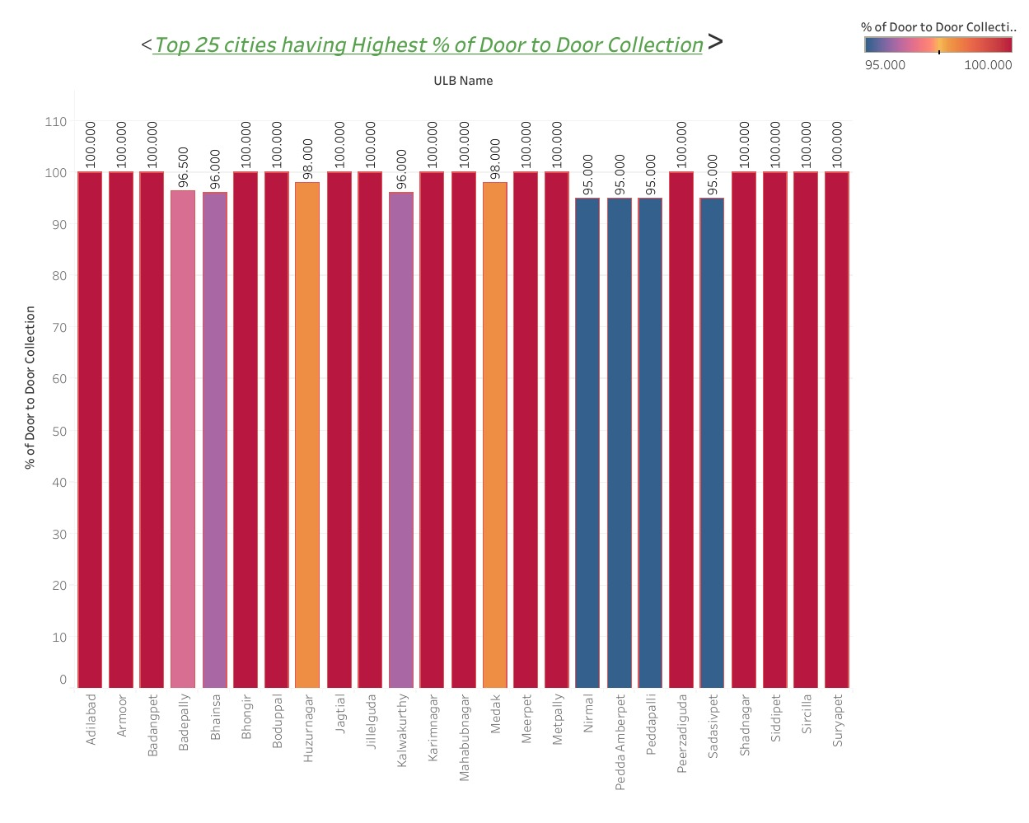

Here the graph points at the top 25 Urban Local Bodies (ULB) that has active door-door collection system. Some of them are- **Adilabad, Armoor, Badangpet, Jagtial, Jillelguda, Karimnagar, Suryapet.**

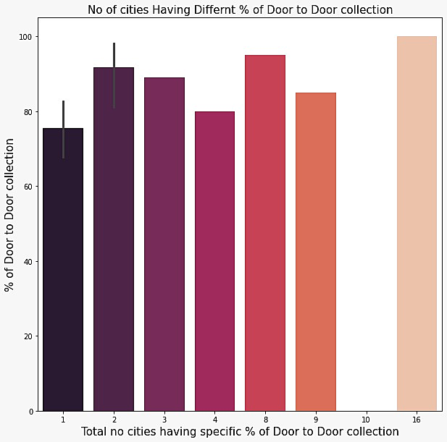

Out of 53 cities there are only **16 cities** that has 100% efficient door-to-door collection waste collection system.

Improvements are expected from other remaining cities, of which, data from 10 cities didn't get.

**SOURCE**

Hospital Waste:

The state has several proper functioning **Government** as well as **Private Hospitals**.

The graph here highlights the TOP 5 Towns which has hospitals that produces high amount of waste under its belt.

1. **Andol-Jogipet, Dubakka, Huzurnagar, Narayanpet and Satupally** are the 5 towns, each locating one **Government Hospital** which is responsible for highest waste generation.
2. Again, **Andol-Jogipet, Dubakka, Huzurnagar, Narayanpet and Satupally** are the 5 Private Hospital Zone/Towns that tops the hospital waste generation. Satupally has the highest the highest number of extensive waste generation Private Hospitals, 20 in totals.

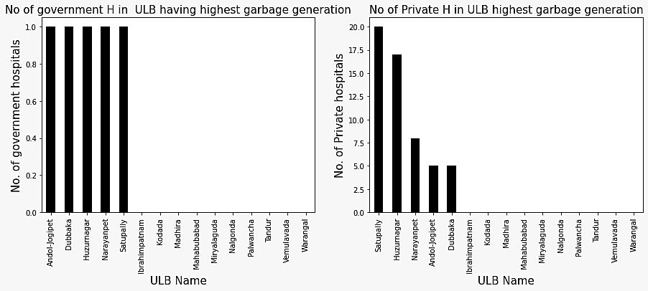

Insights:

Therefore, **Andol-Jogipet, Dubakka, Huzurnagar, Narayanpet and Satupally** are the municipality handling towns that seeks for special attention for its hospital's waste management (bio-medical waste).

**COLLECTION**

Waste/Garbage Collection (Generated Vs Lifted)

Here, the above graph points the cities that generates highest garbage overall-

* **Karimnagar** produces garbage over 200 Mts/day marking the highest production of waste and more than 150 Mts/day of waste generated is lifted or transported from there.
* It is observed that the waste generated is more than the waste lifted/ transported for further processing. Thus, there is a net prevalance of garbage surrounding the area.

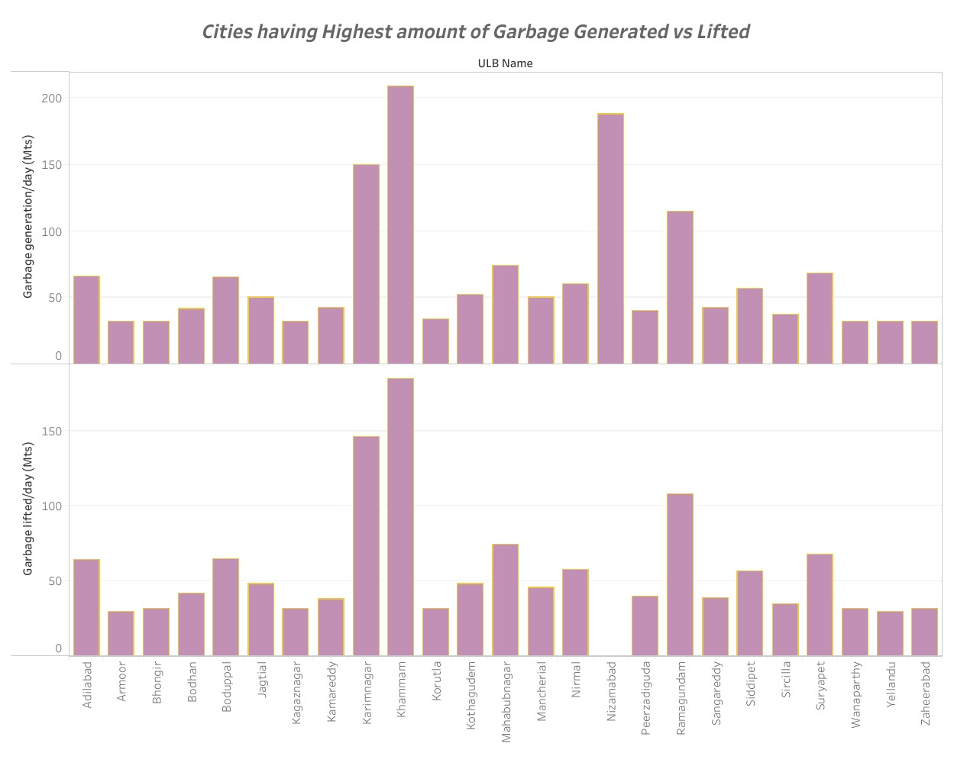

**TRANSPORTATION**

Waste Transporting Vehicles:

* There is a frequent use of 4-wheeled and tricycles to transport garbages.
* In ULB's like Karimnagar and Ramugandam, the number of vehicle reaches upto 180 amd 110 respectively.
* The cities having less garbage generation relies less on pushcarts and autos for waste transportation.

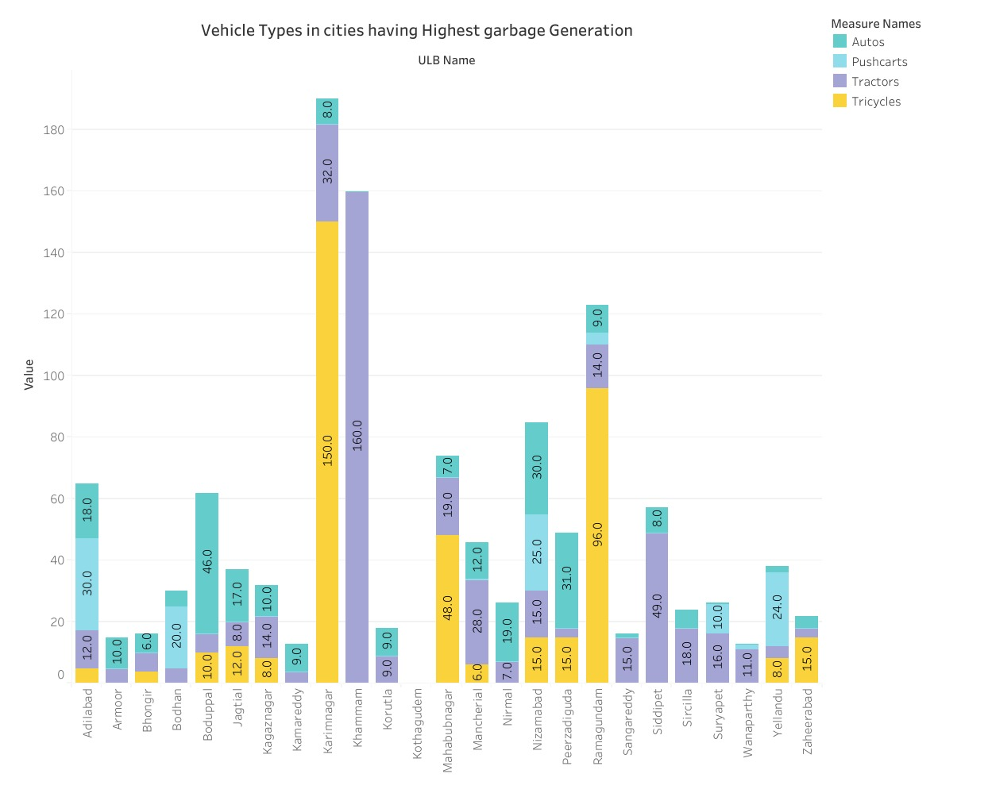

Workers:

Firstly, a huge appreciation for the workers who goes extent to make sure we live in safe, healthy and wholesome environment.

* There are generally two type of workers- Outsourced Workers and Regular Workers. Workers are distributed more in those ULB's where the waste generation is more such as Karimnagar, Khammam.
* The outsourced workers here are high in number than regular workers for obvious economical reason.

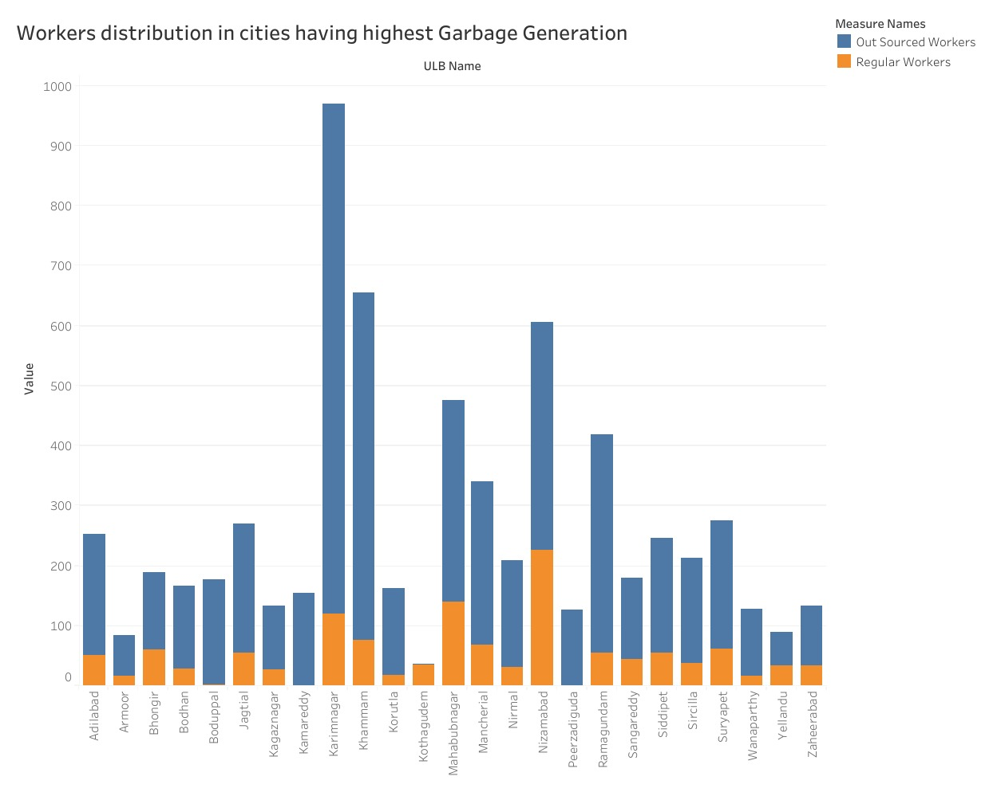

**SANITATION**

Toilets:

Providing facility of sanitations are important and also, there is a need of right infrastructure and maintenance of these facilities in order to maintain hygiene. Like most of the places, The state has toilets biuld throughout.

1. Public Toilets: **Nizamabad** has the highest number of public toilets followed by **Nalgonda**, **Adilabad, khaman.**
2. Community Toilets: Community toilets are biuld in small numbers in regions such as **Jillelguda, Bhainsa, Badepally, kalwakurthy** etc
3. She Toilets: These have been established for women and the data is found for limited Urban Local Bodies (ULB) such as **Kalwakurthy, Ramagundam, Jelpally, karimnagar** etc

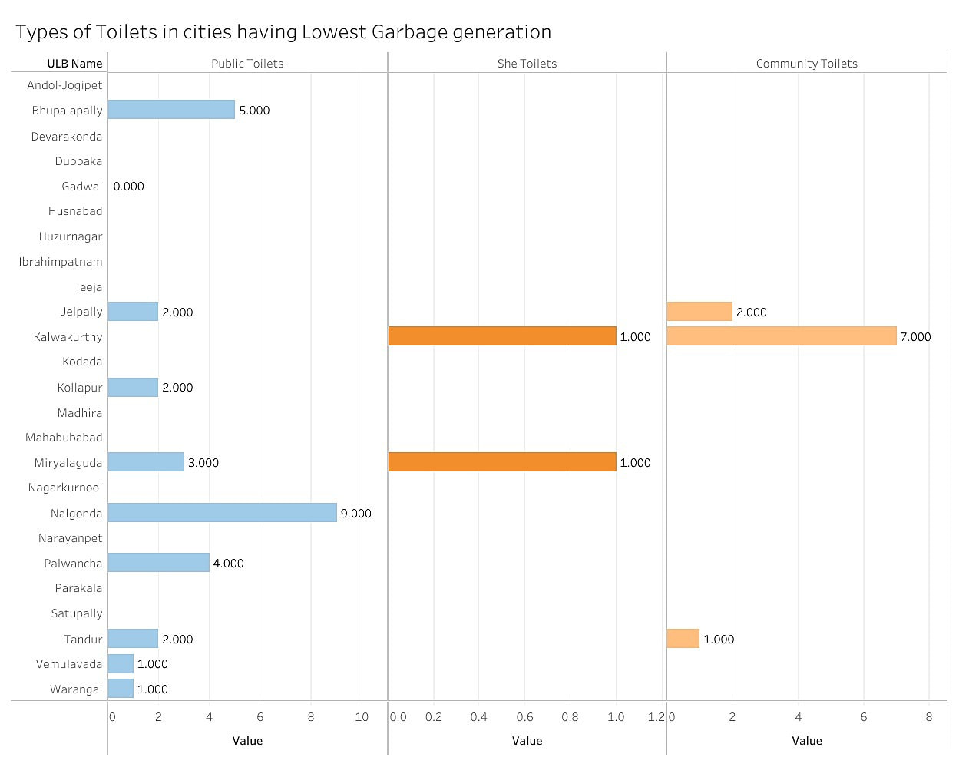



Open Defecation Free (OPF):

As far as India is concern, Open Defecation is still one of the major sanitation impairing issue. Telangana has not been yet Open Defecation-Free State. Under the Swachh Bharat Mission, infrastructural developments are going on to combat the challenge of Open Defecation.

The shown graph throws light on urban declared wards that are free of Open Defecation (ODF Wards) and non-declared ODF wards.

* Miryalaguda, Kodada, Narayanpet are the ULB's that have highest garbage generation but also, are ODF declared wards.
* Warangal, Nalgonda, Mahabubabad, Tandur are the highest garbage generating ODF non-declared wards.

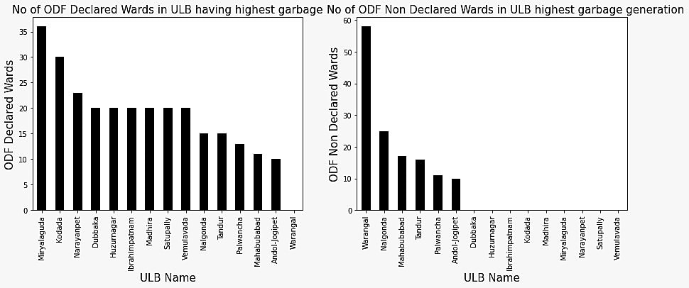

SOLUTION/ INSIGHTS

After in-depth data analsis of the above scenarios and a thorough scrutinisation o the loopholes and mismanagement we have come with some recommendations, adopting which may bring changes and push the whole management towards sustainabilty as par with sustainable goal of **Clean Water and Sanitation**

**Waste to Resource Solutions**

Resource recovery from wastewater facilities in the form of energy, reusable water, biosolids, and other resources, such as nutrients, represents an economic and financial benefit that contributes to the sustainability of water supply and sanitation systems and the water utilities operating them.

Impact on Sanitation-

Resource recovery can transform sanitation from a costly service to one that is self-sustaining and adds value to the economy.

**Sustainable Infrastructural Developments**

Construction of toilets and community toilets in rural areas and urban areas as well making sure that proper cleaning and hygiene is taking place.

Promoting services and treatment facilities related to safe disposal of excreta

Installation and expansion of piped water connections and construction water storage structures.

Implement rainwater harvesting systems to collect and store rainwater for drinking or recharging underground aquifers. Build wells to extract groundwater from underground aquifers.

Provide home water-treatment capability through the use of filters, solar disinfection, or flocculants, to make drinking water safe.

The cost of installing and construction would be high but at the same, one will get impararrel benefits through this.

**Eco-Friendly Low Cost Models**

Filter Straws

Bicycled water purifiers

Solar powered purifiers

**Water quality monitoring and management**

Implementation of metering, leakage detection systems, etc. in the water sector

**Other following solutions**

Promote low-cost solutions, such as chlorine tablets or plastic bottles that can be exposed to sunlight, to improve water quality.

Establishing volunteer-driven initiative which provides organizations committed to increasing safe water and sanitation with plumbers and mechanical trade persons to improve their operations.

***CONCLUSION***

Although the major portion of population resides in the rural zone, still the waste generated is higher for the urban areas, this is due to the development and extensive facility and resource use of the urban population. Hence, here, the focus is given to the Urban Local Bodies. With the data of the situation taken such as the Waste collection from Households, Hospitals and their transportation through vehicles, are put under analysis and the cities with poor waste managements are pointed out. Hence, the first course of recommended solutions must be provided to them and eventually the subsequent cities will follow after depending on the type of facilities, infrastructural development and solution it needs.